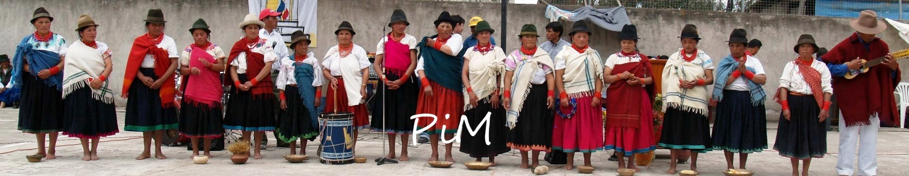Accomplishing More Together

Partners in Missions, Inc.

Founded By
Karvin and Sandy Adams
Former Missionaries to Ecuador
To Partner with the Church in Making Disciples of the Indigenous Peoples of the Americas

Administration: karvinadams@gmail.com
870.500.3576
Promotion: zoniamitchell64@gmail.com

Financial: karla41973@gmail.com
106 S Fairlane Dr – West Monroe, LA 71291

Facebook.com/pimLouisiana
www.partners-in-missions.org

Donations
tithe.ly/give?c=5002127
https://gofund.me/fd22ece0

Approved by IRS as a Nonprofit Religious Organization 501 (c) 3
All Donations - Tax Deductible Used 100% as Donor Designates

<- Areas of Ministry ->

Edifying, Encouraging, and Equipping church leaders

Enlarging God’s Kingdom through evangelism, discipleship, church planting, and radio

Empowering abandoned/abused orphans and women

Educating nationals through scholarships

Encouraging people to get involved in missions

