Donations made to the Louisiana Congregational Ministries of the Church:

***Mail donations to:***

***LCMCOG***

***6701 US Hwy 165 N***

***Monroe, LA 71203***

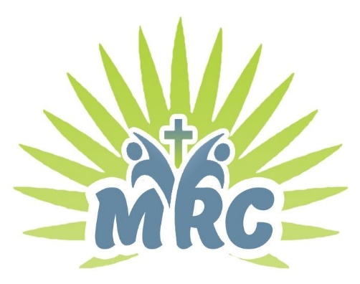

Donations made to the Ministry Retreat Center

Palmetto, La.

Go to: <https://paypal.me/cogmrc>

Donations made to the Pollock Campground Association:

**Mail donations to:**

**Pollock Campground Association**

**6701 US Hwy 165 N**

**Monroe, LA 71203**

