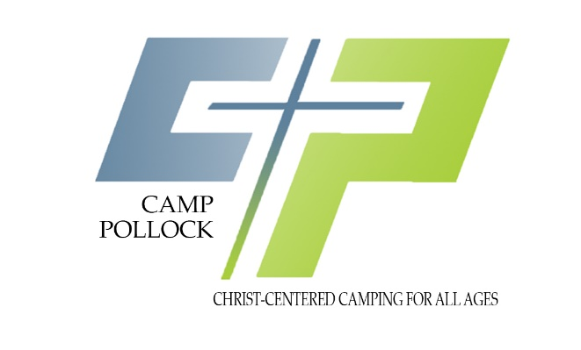

August 13, 30224

**Above and Beyond**

​

​

​

Hello Friends!

​

The Annual PCA Offering was received at the 2024 Camp Meeting and was beyond the $20,000 goal.  The YTD total of that special donation is $39,019.00. PTL! What a blessing! The Pollock Campground Association appreciate your prayers, labor and last, but not least, your donations that are given to the PCA. These monetary donations will help to offset the uprising cost of camp insurance and utilities.

​

In 2023-2024, The Property Ministry Team has replaced three cabin roofs, installed LED lighting throughout the grounds, repaired rotted boards on cabins/dorms, replaced air conditioners and replaced the culvert by the pond, etc.

​

For the those who do not have the opportunity to visit or stay on our Pollock campground, you may have wondered from time to time, why we are continually asking for your financial support—where do the funds go? We depend on you to keep our grounds maintained. The Property Ministry Team members are doing the best we can to wisely spend the available budgeted monies to make needed improvements.  If you or your church is able to give to this cause, please send your check to Pollock Campground Association, Att: Trey Oldham, Treasurer, 6701 US Hwy 165, Monroe, LA 71203. To designate your donations for a specific project, such replacing roofs, please put "Camp Development" in the memo line. If you want your giving to go toward the General Fund Budget, which will cover all expenses of the campground, please write General Fund on the memo line.

​

Thank you ahead of time for your generosity in giving “above and beyond” the usual. I know God will bless you “above and beyond” what you may expect as you generously share in God’s work here at Camp Pollock.

​

Sincerely in Christ,

​

Your Pollock Campground Association Property MT

Brad Beebe, Chairman, PCA Property Ministry Team

Jackie Paulk, Vice Chair

Barry Beebe

David Ford

Carl Smith

THE PCA ASSOCIATION BUDGET CATEGORIES

* Camp Pollock Maintenance, Insurance, Utilities, etc.
* Youth Camp Expense
* CampMeeting Expense
* **40%** State Office Secretary Wages
* Business MT Expenses
* Caretaker’s Wages
* Camp Development (roofs, buildings, large appliances, etc)