2023 YOUTH CONVENTION
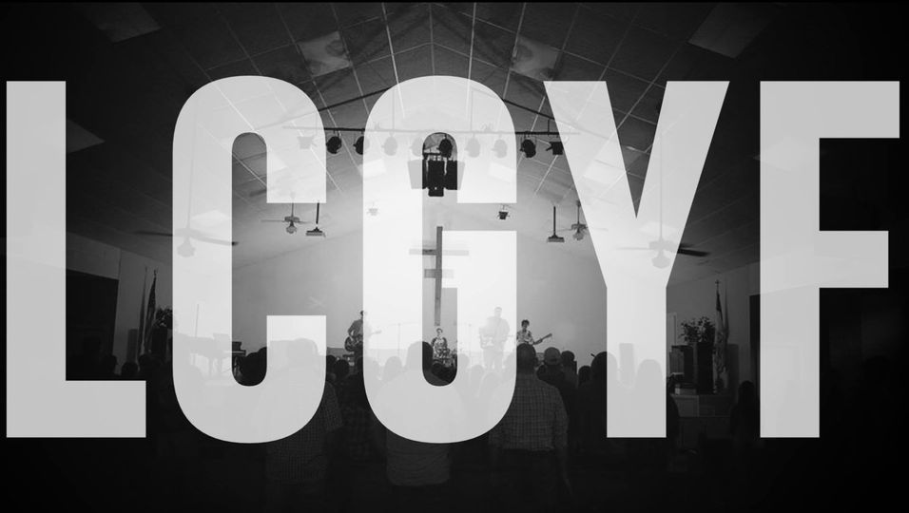

2023 YOUTH CONVENTION SAVE THE DATE... NOV 17-19!!!!

It may still feel like summer, but we are NOW into the fall and that means the LCGYF State Youth Convention is right around the corner! We’ve had a challenge over the last several months finding a venue and after some creative thinking, we have landed in Lake Charles for November 17-19, 2023. We have contracts with two hotels about a mile away from Christ Community Church, our host for this year’s Convention.

Convention registration this year will be $60 for students and leaders. We are not equipped for debit/credit cards and to keep from having to trade checks, you won’t have to pay your registration until the Friday of Convention.

Important dates:
-September 18: Time that Churches began to book rooms at the Hampton Inn and Holiday Inn and Suites in Lake Charles (information and links provided below).
-November 1: Reserved rooms will be released so make sure you have reservations by this date.
-November 5: Pre-registration deadline. We know that lists change all the way until a couple of hours before the event. Your pre-registration list will allow us to order Convention shirts. You will only have to pay the full registration for the people who attend. However, you will be charged $15 for every shirt you order without an attendee. If your list changes before November 5th, please let us know and we’ll change your list. If your church submits a pre-registration and later decides not to attend, please pay for the shirts and we will find a way to get them to you. We will order a few extras for students who decide to attend after the deadline, but these shirts will be given only until we run out.
-November 13: Room Cancelation deadline for Holiday Inn and Hampton Inn
-November 17: 2023 LYGYF Youth Convention begins at Christ Community Church in Lake Charles

Hotel information:
Holiday Inn and Suites- no breakfast included; $119/night
2940 Lake St. Lake Charles, LA 70601
(40) Two queen beds
(9) One King, One sleeper sofa
Louisiana Church of God Youth Fellowship
https://www.holidayinn.com/redirect?path=rates...
Group Code: CGY

Hampton Inn & Suites- breakfast included $120/night
3175 Holly Hill Road Lake Charles, LA 70601
(20) Two queen beds
https://group.hamptoninn.com/t9qggc
The group code is LCG for the group.

